DIS- Indus Valley-Fertility figurine

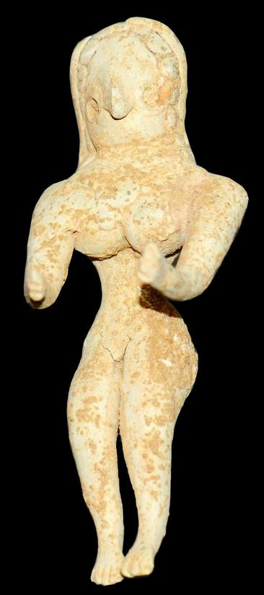 US $2,350.00

Culture- Indus Valley.  
  
Date-  2nd - 1st millenium B.C.Material- Terracotta.  
  
Condition- Intact, with custom display stand.  
  
Provenance- Ex: European art market; Ex: American private collection.  
Measurements- 4 3/8 in. High (10.4 cm.)

A very rare fertility statue, especially in such a state of preservation.